Lab B - Computer and Network Discovery

Timothy Victori

Arizona State University

IFT 202

Gary Grindle

9/1/2024

Part 1

Task 1
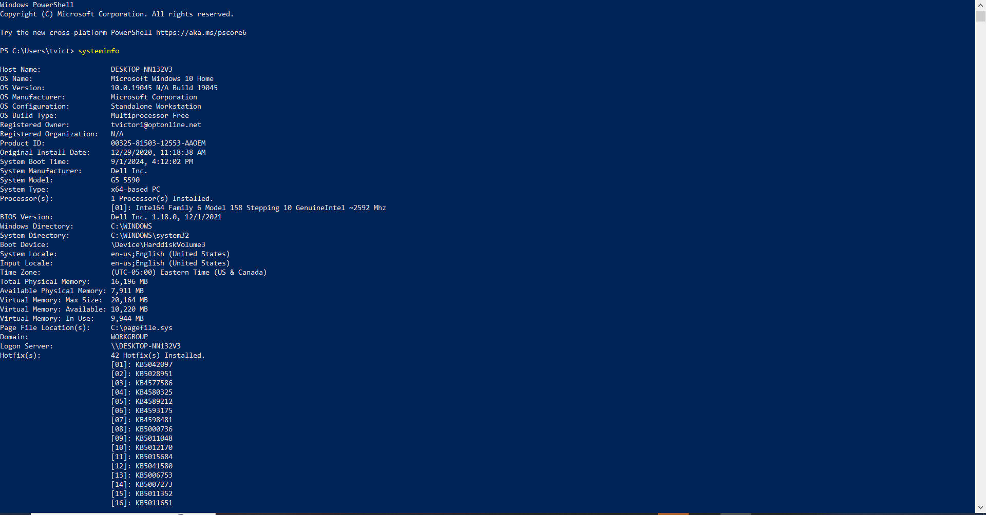
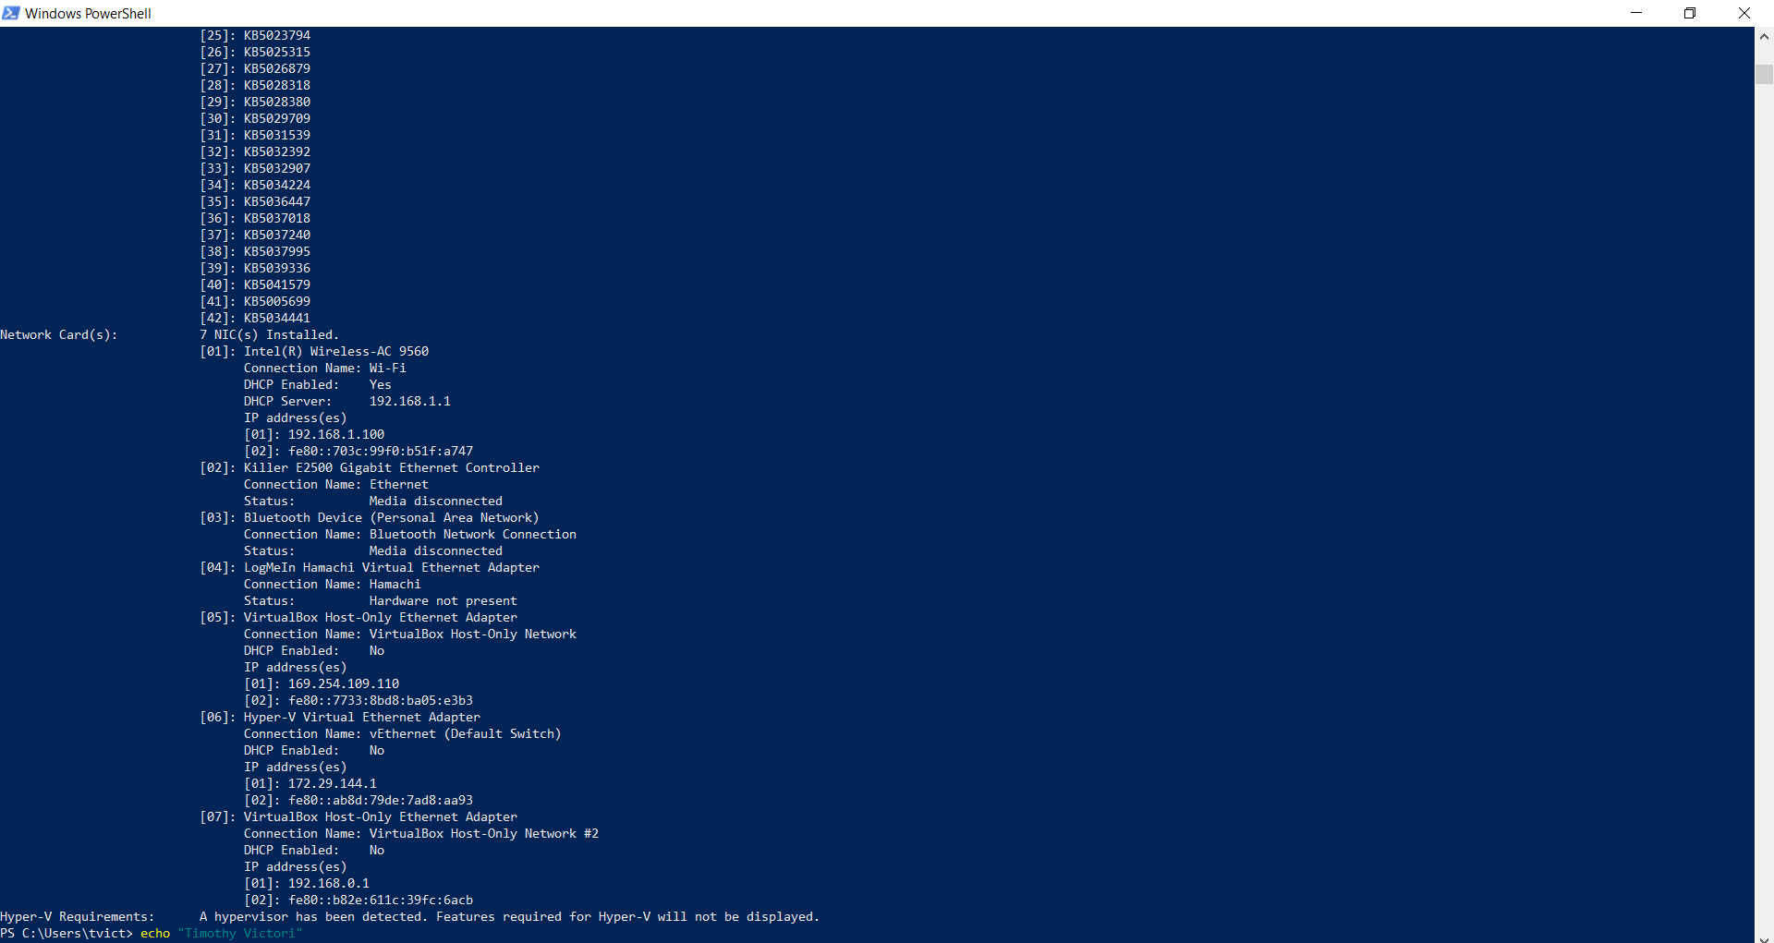

Task 2
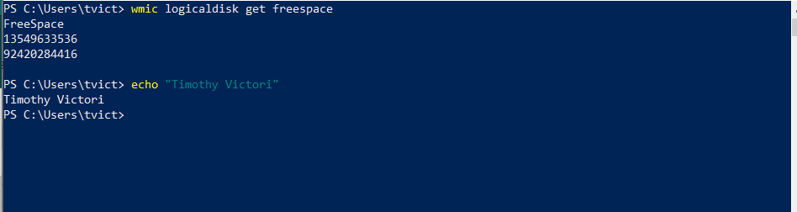

Task 3
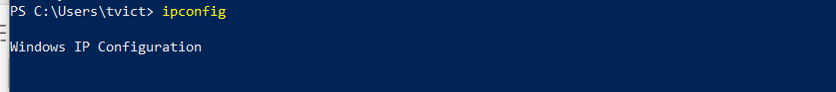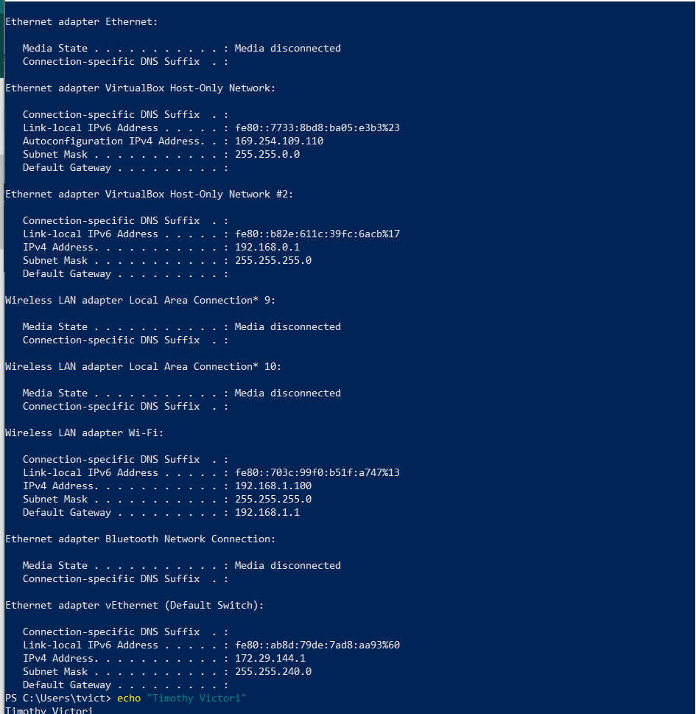

Task 4
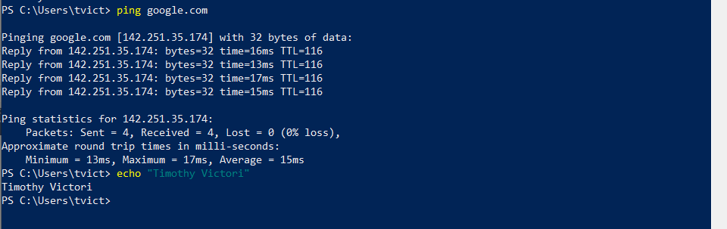

Task 5
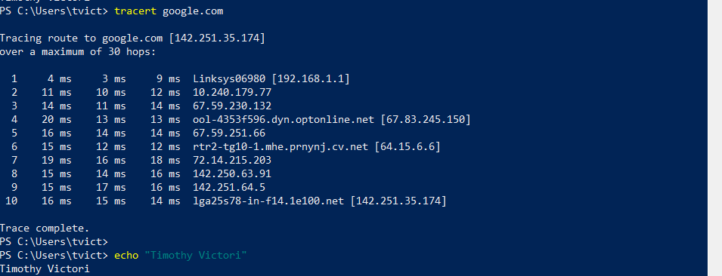

Task 6
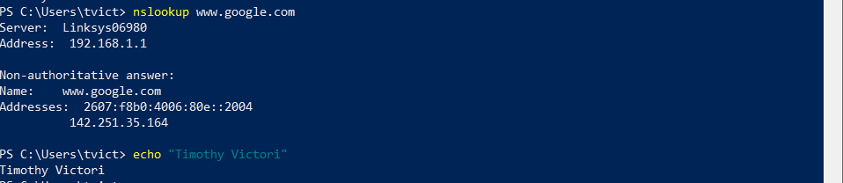

Part 2

Task 1
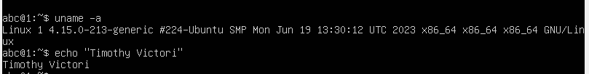

Task 2
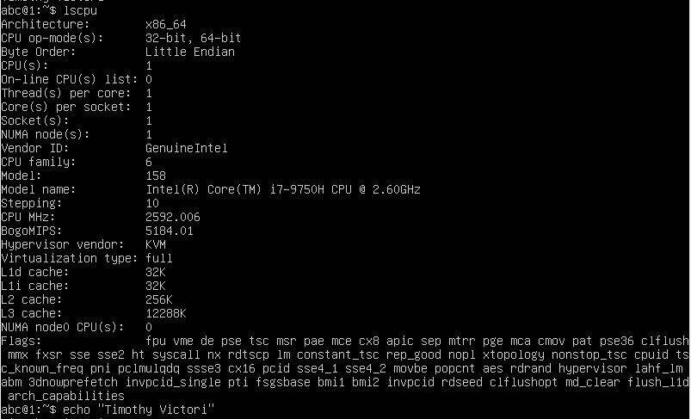

Task 3
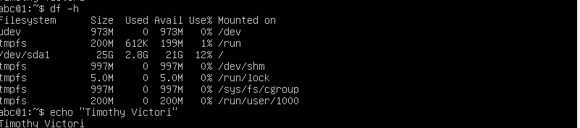

Task 4
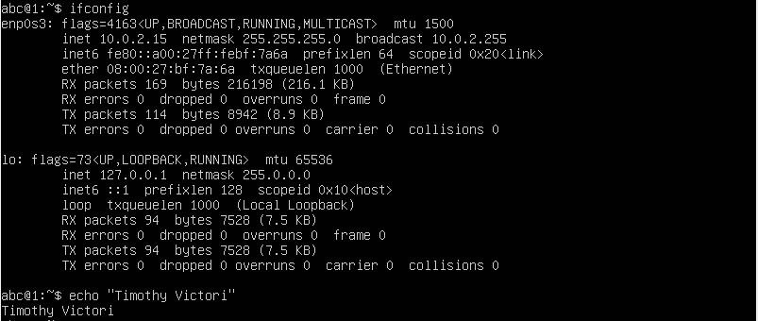

Task 5
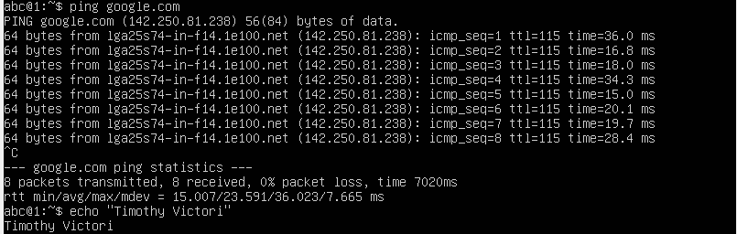

Task 6
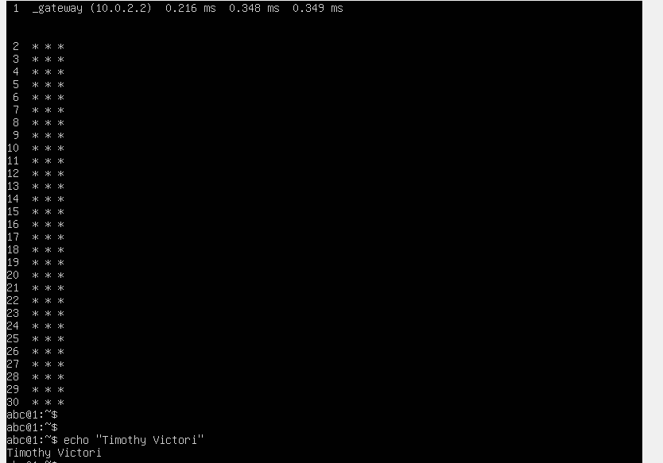

Task 7
